**Eric Nay**

**The Group of Seven Word Count: 488**

The Group of Seven was a group of Canadian landscape painters working in the early 1900s who developed a distinct style of painting that was tied to the evolution of Canada’s national identity. The group’s work focused on capturing the natural beauty of Canada’s vast wilderness through a self-proclaimed “Canadian” style that evolved following group expeditions into the Canadian landscape. The original members of the group were Franklin Carmichael (1890–1945), Lawren Harris (1885–1970), A. Y. Jackson (1882–1972), Frank Johnston (1888–1949), Arthur Lismer (1885–1969), J. E. H. MacDonald (1873–1932), and Frederick Varley (1881–1969). The group’s members were based in Toronto, Ontario, and included fine artists, commercial artists and graphic designers who would meet at the Toronto Arts and Letters Club. Tom Thomson (1877-1917) was the group’s spiritual founder, even though he died three years prior to its official formation. Membership would expand in later years to include A. J. Casson (1898–1992), Edwin Holgate (1892–1977) and LeMoine Fitzgerald (1890–1956). Emily Carr (1871-1945) is also associated with the Group of Seven, but was never a member. The Group of Seven was disbanded in the 1930s.

The individual works of the members of the Group of Seven varied, but each one shared similar techniques and stylistic approaches with the common goal of representing the “untouched” Canadian landscape through a uniquely Canadian style. The group claimed to distance itself from European styles, but references to Impressionism, Post-Impressionism and Art Nouveau are clearly evident in its work. The Group developed a unique, rugged approach to painting that reflected its desires to develop a distinctly Canadian style. The Group worked directly from nature in frequently very challenging physical environments, which forced them to adapt to painting in the frigid cold and to whatever transport that could accommodate their travel, such as from within the bowels of a canoe. The resulting need for both speed and agility in technique provoked a spontaneous form of painting. Vast vistas framed by pine boughs were captured on canvases using broad, fast brush strokes followed with thick, bold splashes of colour applied in thick layers without the benefit of preliminary sketches or careful premeditation*.* The Group of Seven’s work ultimately gained widespread popular support within the art community and Canadian popular culture. Its collective body of work now forms the core of permanent art collections at institutions across the country including the National Gallery of Canada, the Art Gallery of Ontario and the McMichael Canadian Art Collection. Contemporary critics have since raised numerous issues about the intentions, methods and rhetoric of the group, specifically criticizing the group’s complete dismissal of Canada’s indigenous population with its rich artistic and cultural traditions in areas that the Group of Seven had labeled as “untouched” on their expeditions.

**References and further reading**

# Silcox, D. (2006) *The Group of Seven and Tom Thomson*, Richmond Hill, Ontario: Firefly Books, Ltd.

# Tooby, Michael, (1991) *The True North: Canadian Landscape Painting 1896-1939*, London : Lund Humphries in association with Barbican Art Gallery.

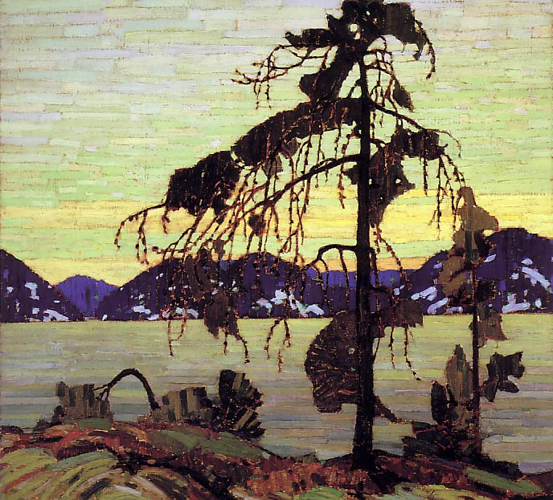

Tom Thomson, *The Jack Pine*, 1916-1917

Canadian, 1877 - 1917   
oil on canvas  
127.9 x 139.8 cm  
Purchased 1918  
National Gallery of Canada (no. 1519)

<http://www.gallery.ca/en/see/collections/artwork.php?mkey=11056>